**Wallkill Cheerleading Agreement**

In order to have a positive atmosphere for the team all players must attempt to discipline themselves. It has been my observation that the athlete, who lacks in self-discipline, is disruptive to the rest of the team. Therefore, I have set up certain guidelines for the student-athletes that I feel are necessary, but fair. These guidelines are established to help each student-athlete become a more **responsible and professional** person in and out of the cheerleading setting. I will attempt to help each student-athlete follow the guidelines, but in essence the real effort must come from each individual. It is my feeling that if each student-athlete can adhere to the policies set forth, we will truly have a winning season.

The following in addition to the Wallkill Athletic Handbook are the rules and regulations that you are required to follow in order to participate in the Wallkill cheerleading program. Please read this agreement carefully so that you know what is expected of you upon a **successful tryout**.

* **The purpose of the cheerleading program is to:**
  + Create school spirit and pride in our school.
  + Promote interest in school activities.
  + Exhibit quality performances at school games/competition.
  + Develop character, including, but not limited to, responsibility, cooperation, self-respect, and honesty.
  + Teach teamwork.
* **Eligibility**
  + Each member must maintain eligibility.
    - **One** missing member, even for **one** day, impacts the entire cheerleading team. A missing member for an extended period of time seriously impacts the team’s performances.
  + Each member must submit and be cleared through Family ID in order to participate.
  + Each member must have a signed Cheerleading Agreement prior to participation.
* **Attendance**
  + If a member misses a **game or practice** due to a medical appointment, he/she must let the coaches know **a day ahead of time** and bring a note signed **by your parent** to Coach Roberta/Mrs. Williams. **This is the ONLY way that your absence will be EXCUSED.** 
    - **Without a note, the member will not be permitted to participate in the next game.**
  + All members must attend each practice, game or activity in its **entirety**. If, for any reason, you have to leave early, you must inform the coach **at least one day before.**
* **Uniform**
  + Uniforms will be provided by the school and will be property of the cheerleading team, pom poms will be a part of the uniform and must be returned.
  + It is the responsibility of the cheerleader to buy her/his own sneakers, bow, and black briefs/pros before the first scheduled game/competition. **These items must be worn to each and every game/competition.**
  + Each member must keep his/her uniform in good condition and clean. Before turning in a uniform at the end of the year, it must be cleaned and handed in in a bag with the cheerleaders name on it.
  + **Each cheerleader must maintain the integrity of the uniform.** Cheerleaders may not roll up their skirt to make them shorter or hem skirts to make them tighter. The coach will make sure you have a uniform that fits you.
  + **Jewelry is prohibited during practice, games/competitions, and activities.**
    - Do not wear jewelry on the bus, at practice, or at games, (any time you are under the supervision of the cheerleading coach).
  + **Nails – acrylics are acceptable BUT** Nails are NOT to be visible beyond the end of the fingers when viewed from the palm side of the hand held in a vertical position. They should be squared off with rounded ends. No nail polish can be worn for games or competitions.

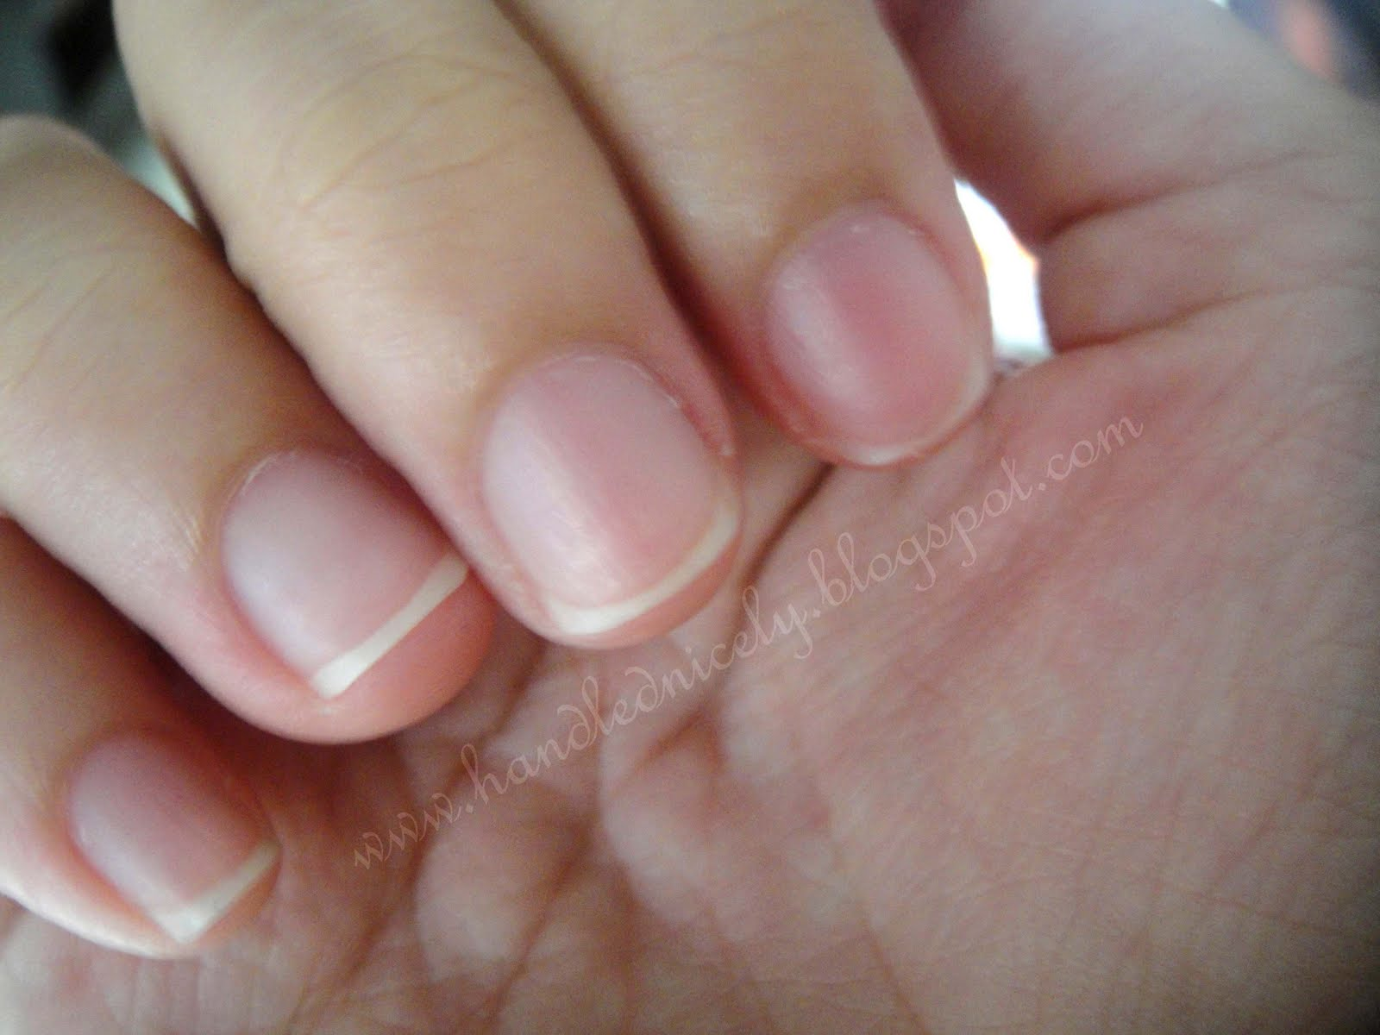

* + A uniform provides consistency and displays a united team. To show that we are a cohesive team, all hairstyles will be identical: all hair must be pulled back into a tight pony-tail. At no time will we have loose hair (unless the hair is too short to pull back into a ponytail).
* **Medical**
  + Each member must have a complete physical exam before tryouts.
  + The Family ID must be filled out during the registration time for fall season.
* **Academics:** 
  + each student-athlete is expected to adhere to the academic requirements set forth by the school and the athletic department. Failure to do so may result in dismissal from the team. In addition, each student-athlete is expected to attend every scheduled class the day of a game. Anyone failing to attend class the day of a game will not participate in any stunting/tumbling.
* **Character**
  + Team members should set a good example at all times.
  + Team members must be courteous and friendly to all team members, as well as members from other teams.
  + Team members must be respectful to the coach and to other members.
  + Smoking, drinking and/or drug use including posting pictures and comments on social media are grounds for suspension or dismissal as per the Athletic Handbook.
  + Remember you must also adhere to the Rules and Regulations in the Athletic Handbook.
* **Commitment:** 
  + Being part of this team requires a full-time commitment on each team member’s part. This includes: being at every practice and team event on time and working to the best of her/his ability in school and at practice each day. Failure to do this will result in the lack of participation time and possible dismissal from the team.
  + ** If a cheerleader quits the team, they are not allowed to try out the following season.
* **Participation Policy**
  + Being part of an athletic team requires teamwork and cooperation between players, parents, and coaches. In order to have a fun, successful, and skilled program, coaches must make certain decisions that they feel is in the best interest of the **“TEAM.”** Coaches understand that each member of the team would like to participate in as many performances/stunts as possible. However, due to many variables, some players will not participate as much as others in performances and coaches cannot guarantee that each cheerleader will have the same position as prior events/years. As a coach, I will do the best job I can to have each cheerleader participate in the performances. But unfortunately, with a large roster and other variables, not all cheerleaders will participate in the positions they desire during performances in games and other events.

Understanding of this policy by both cheerleaders and parents is essential for a successful cheerleading program.

* **Training Regulations**:
  + I expect student-athletes to be willing to follow a stricter set of rules in order to better prepare themselves for participation at the highest skill level which they are capable.
  + Possession/Consumption (including being under the influence of) and/or distribution, other than prescribed by a physician for personal use, any controlled drug and/or intoxicant, at any time during that sports season whether during school, at a school activity, on school property, or at locations off school property is prohibited.
  + Possession or use of tobacco, electronic cigarettes, rolling papers, personal vaporizers, e-liquids and any electronic nicotine device or paraphernalia associated with these products, lighters, matches, etc., is prohibited.

**\*\*** Failure to comply with the above will result in specific disciplinary actions written in the WCSD Athletic Handbook on pages 6-8.

**Please sign this portion of this form and retain top portion.**

I have read, understand, and agree to the rules and regulations of the cheerleading constitution.

____________________________ Member’s Signature

____________________________ Member’s Name Printed

____________________________ Parent/Guardian’s Signature

____________________________ Parent/Guardian’s Name Printed